|  |  |  |  |
| --- | --- | --- | --- |
| **GOOD COUNSEL COLLEGE** | |  |  |
| **RELIGIOUS EDUCATION** | |
| STUDENT NAME: |  |
| TEACHER: |  |

|  |  |  |  |  |  |
| --- | --- | --- | --- | --- | --- |
| **ASSESSMENT CONDITIONS** | | | |  | **ASSIGNMENT**  **Analytical Essay** |
| **Date Received:** | Week 5 | **Draft Due: Week 8** |  |  |
| **Time:** | 5 weeks | **Date Due:**  **Week 10** |  |  |

|  |  |  |  |  |  |  |  |
| --- | --- | --- | --- | --- | --- | --- | --- |
| Assessment Instructions:   1. Assignment must have a title page. 2. Assignment must be word processed using Calibri size 12 3. 600 – 800 words 4. APA referencing required | | | | | |  | **Year 10**  **SEMESTER 1, 2022**  **INSTRUMENT NO.**  **1**  **TOPICS ASSESSED:**   * **The Mystery of God**   **CRITERIA ASSESSED:**   * **Knowledge & Understanding** * **Skills** |
|  | | | | | |  |
| **SUMMARY OF RESULTS** | | | | | |
| **CRITERIA ASSESSED** | **STANDARD** | | | | |
| **A** | **B** | **C** | **D** | **E** |
| Knowledge & Understanding |  |  |  |  |  |
| Skills |  |  |  |  |  |
|  | | | | | |
| *COMMON CURRICULUM ELEMENTS* | | | | | |
| * Recalling/remembering * Recording/noting data * Using correct spelling, punctuation, grammar * Using vocabulary appropriate to a context * Setting out/presenting/arranging/displaying * Searching and locating items/information | | | | | |

**context**

Throughout this term, we have been looking at representations of God in the scriptures and Christian writings, creation and in artwork. You have been invited by the Innisfail Art Society to look at the representation of God in two of the artworks provided and submit an analytical essay which explains the human understandings of the mystery of God which could be interpreted from such artworks.

**Task**

**Analyse two of the artworks provided** (you may also choose an artwork to be negotiated with your teacher). Write a **600 – 800 word analytical essay** which evaluates how such artworks show the human understanding of the mystery of God.

Your essay must:

* Identify the human understanding of the mystery of God that could be seen in the artworks, referring to the **subjects, symbols, objects, shapes and title of the artwork**.
* **Analyse** the meaning that could be observed about the **human understanding of the mystery of God and his relationship with mankind**. **Explain** how the **subjects, symbols, objects, shapes and title** of the artwork attempt to **describe the nature of God**. (God as creator, shepherd, law-giver, merciful Father; or images of God in creation; or understandings of God as Trinity – Father, Son and Holy Spirit)
* **Evaluate** **how the artworks reflect the human understanding of God** and **his relationship with mankind** by using **scripture to support** your reasoning.
* **Evaluate** whether the understanding of God in this image is relevant for modern Australian audience.

Include **in-text referencing and a bibliography**

|  |  |  |  |
| --- | --- | --- | --- |
| **CHECKLIST:** | | | |
| **Date** | **Tasks to be completed** | **Progress comments** | **Teacher’s signature** |
| **Artworks chosen** | End Week 5 |  |  |
| **Analysis template due** | End Week 6 |  |  |
| **Essay draft due** | End Week 8 |  |  |
| **Final essay due** | Week 10 |  |  |

**ANALYSIS PLANNING TEMPLATE**

|  |  |  |  |
| --- | --- | --- | --- |
| **What do I observe about this image? (describe the subjects, objects, shapes, placement – foreground, middle ground, background)**  **What are the titles of the artworks?** | **What meaning about the nature of God or his relationship with mankind could be read from these observations?** | **How does this link to images of God discussed in this unit?** | **Which scriptures/Christian writings could I use to support this meaning/image of God?** |
|  |  |  |  |

**Critical Analysis Structure Checklist**

|  |  |
| --- | --- |
| **INTRODUCTION** | |
|  | **Use a hook – quote, interesting fact – to attract the reader’s interest** |
|  | **Introduce the artists and artworks** |
|  | **Introduce your thesis statement or point of view – what is the human understanding of the mystery of God that is seen in your chosen artworks?** |
|  | **Provide an overview of your key points – what are the two images of God you will be discussing that are linked to your chosen artworks?** |
|  |  |
| **BODY PARAGRAPH 1** | |
|  | **Topic Sentence** |
|  | **Identify an image of God (a human understanding of the Mystery of God) which is relevant in your chosen artwork.** |
|  | **Analyse and explain how this image of God is reflected in scripture.** |
|  | **Evaluate how your chosen artwork represents this image of God. If using more than one artwork, explain how the artworks are similar or different in their representation of God.** |
|  | **Support your explanations using scriptural/other evidence/quotes.** |
|  | **Concluding sentence** |
|  |  |
| **BODY PARAGRAPH 2** | |
|  | **Topic Sentence** |
|  | **Identify an image of God (a human understanding of the Mystery of God) which is relevant in your chosen artwork.** |
|  | **Analyse and explain how this image of God is reflected in scripture.** |
|  | **Evaluate how your chosen artwork/s represents this image of God. If using more than one artwork, explain how the artworks are similar or different in their representation of God.** |
|  | **Support your explanations using scriptural/other evidence/quotes.** |
|  | **Concluding sentence** |
|  |  |
| **CONCLUSION** | |
|  | **Summary of the main points – your two images of God discussed in each paragraph** |
|  | **Summary of the main point of view – the human understanding of the mystery of God.** |

**Bibliography**

**Use the table below to help you record the resources you have accessed. You will be required to prepare a bibliography as per the College’s required format.**

**Book Reference**

|  |  |  |  |  |  |
| --- | --- | --- | --- | --- | --- |
| **Author** | **Date of Publication** | **Title of Book** | **Publisher** | **Place of Publication** | **Inclusive Pages** |
|  |  |  |  |  |  |
|  |  |  |  |  |  |

**Internet Reference**

|  |  |
| --- | --- |
| **Web Address** | **Date Accessed** |
|  |  |
|  |  |
|  |  |
|  |  |
|  |  |
|  |  |

**Other References (eg. Media Resources)**

|  |  |
| --- | --- |
| **Title of Program** | **Date** |
|  |  |
|  |  |

*God as architect of the world, folio 1 verso of a moralized Bible, from Paris, France, ca 1220-1230, Osterreichische Nationalbibliothek*

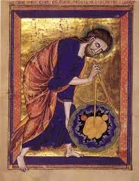

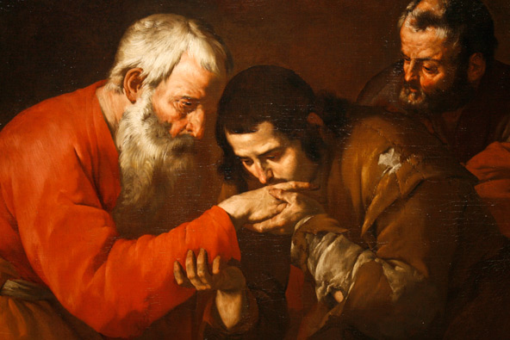*A painting titled “The Return of the Prodigal Son,” by an unknown artist, is pictured at the Museum of Biblical Art in New York.*

|  |  |  |  |  |  |
| --- | --- | --- | --- | --- | --- |
|  | **A** | **B** | **C** | **D** | **E** |
| **Knowledge & Understanding** | The student:   * Comprehensively explained human understanding of the mystery of God that could be seen in the artworks, referring to the **subjects, symbols, objects, shapes and title of the artwork.** * Comprehensive **Analysis of** the meaning that could be observed about the **human understanding of the mystery of God and his relationship with mankind.** | The student:   * Explained in detail human understanding of the mystery of God that could be seen in the artworks, referring to the **subjects, symbols, objects, shapes and title of the artwork.** * Explained in detail the meaning that could be observed about the **human understanding of the mystery of God and his relationship with mankind.** | The student:   * Demonstrated human understanding of the mystery of God that could be seen in the artworks, referring to the **subjects, symbols, objects, shapes and title of the artwork**. * Demonstrate the meaning that could be observed about the **human understanding of the mystery of God and his relationship with mankind.** | The student:   * Described human understanding of the mystery of God that could be seen in the artworks, referring to the **subjects, symbols, objects, shapes and title of the artwork**. * Described the meaning that could be observed about the **human understanding of the mystery of God and his relationship with mankind.** | The student:   * Made statements about human understanding of the mystery of God that could be seen in the artworks, referring to the **subjects, symbols, objects, shapes and title of the artwork.** * Made statements about the meaning that could be observed about the **human understanding of the mystery of God and his relationship with mankind.** |
| **Skill** | The student:   * **Comprehensively evaluates** **how the artworks reflect the human understanding of God** and **his relationship with mankind** by using **scripture to support** your reasoning. * **Comprehensively evaluates** whether the understanding of God in this image is relevant for modern Australian audience. | The student:   * **Effectively evaluates** **how the artworks reflect the human understanding of God** and **his relationship with mankind** by using **scripture to support** your reasoning. * **Effectively evaluate** whether the understanding of God in this image is relevant for modern Australian audience. | The student:   * **Demonstrates some evaluation of** **how the artworks reflect the human understanding of God** and **his relationship with mankind** by using **scripture to support** your reasoning. * **Demonstrates some evaluation of** whether the understanding of God in this image is relevant for modern Australian audience | The student:   * **Variable evaluation of** **how the artworks reflect the human understanding of God** and **his relationship with mankind** by using **scripture to support** your reasoning. * **Variable evaluation of** whether the understanding of God in this image is relevant for modern Australian audience | The student:   * **Basic evaluation of** **how the artworks reflect the human understanding of God** and **his relationship with mankind** by using **scripture to support** your reasoning. * **Basic evaluation of** whether the understanding of God in this image is relevant for modern Australian audience |
| **Teacher comments:** | | | | | **Teacher Signature:** |
| **Date:** |

## Yr 10 Marking Criteria

**Note there is a book called OUR MOB GOD’S STORY in the Library and with Mrs Luxford which has additional pieces by indigenous artists which you can use with teacher approval**

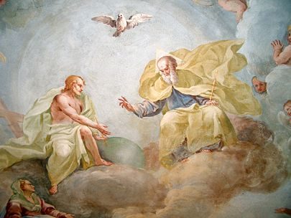*Holy Trinity, fresco by Luca Rossetti da Orta, 1738–9 (St. Gaudenzio Church at Ivrea)*

*“Good Shepherd.” Oil painting by Yongsung Kim.*

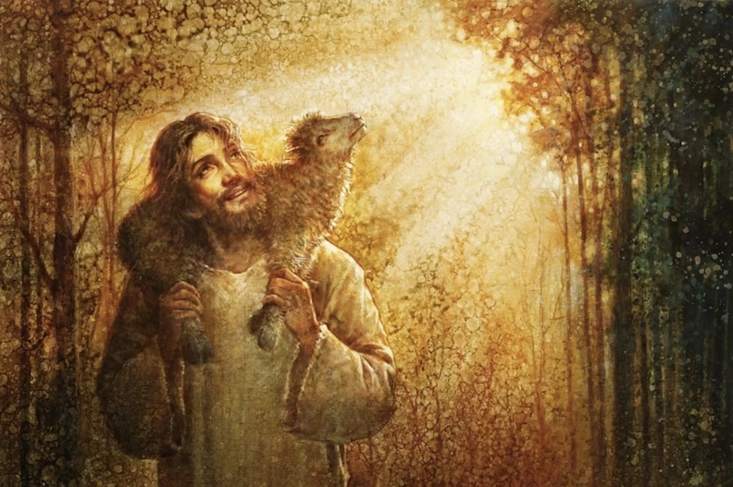

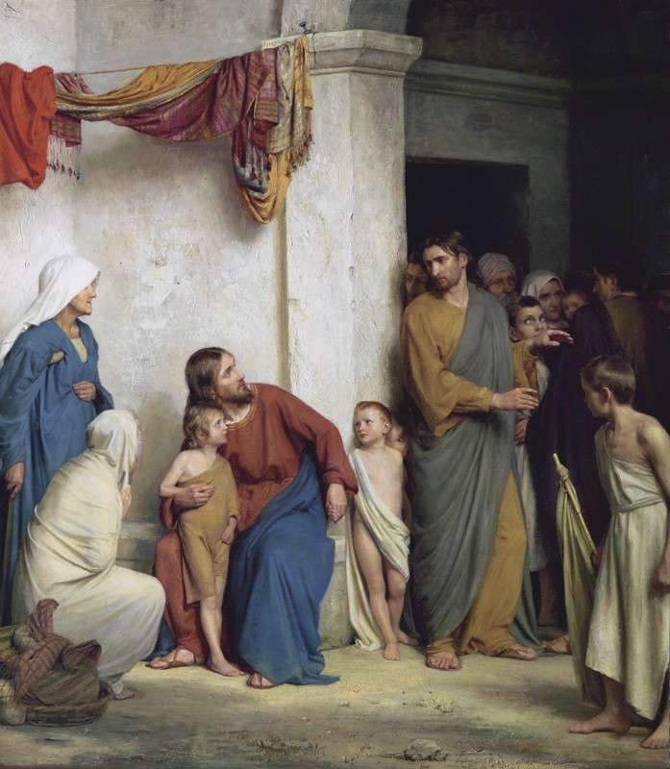

**Christ blessing the children Carl Bloch**

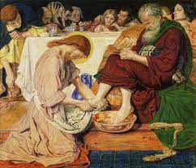

**Jesus washing Peter’s feet Madox**

*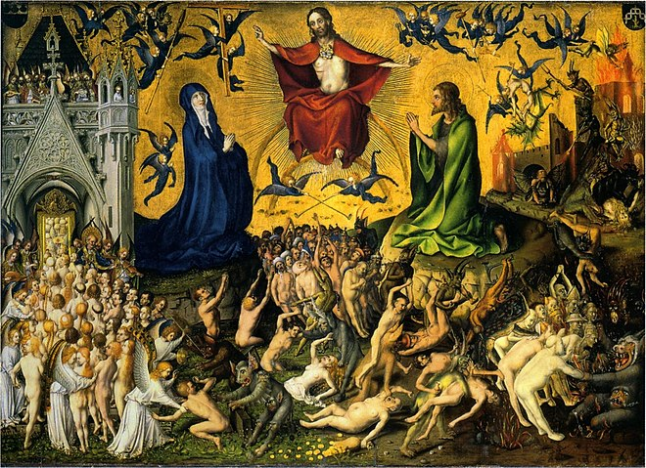Stefan Lochner, “Last Judgment”, c. 1435. Wallraf-Richartz Museum, Cologne*

*TGTgerer*